Conditioning Game Design Document
By Pranay Vinod

Table of Contents

One Pager 1
Tagline 1
One Liner 1
Concept 1
Genre 1
Target Audience 1
Gameplay 1
Initial Ideation Phase 2
Characters 2
The Main Character 2
ERIS 2
The Twin Titan Corporation 3
Narrative 3
Main Story 3
ERIS_47 backstory 7
Project Backstory 9
Twin Titans Corporation Backstory 9
Gameplay & Design 11
Controls 11
Camera 11
Research 11
Simulation Concept 11
Implementation 11
Supporting Characters 12
Implementation 13
Method of Manipulation- 14
Implementation 14
Relationship between main character and supporting character- 15
Implementation 16
Implementation 18
A villain for the protagonist to fight 18
Implementation 21
Environmental Sound- 21
Implementation 22
Immersion Plan 22
Game Flow Chart 23
Game Flow 23
Narrative Flow 23
Starting Cutscene 24
Secret Ending Cutscene 25
Game-Over Flow 26
Dialogue Script 26
Mood Board 27
Environment 27
Characters 34
Lighting 36
Maze structure Reference 37
Maze Intensity Reference 39
References 40
Assets Used in Game 40

One Pager

Tagline
Seek the hidden truth.

One Liner
When a person has nothing left to lose and is given a righteous cause, to what extend would they go to do the right thing?

Concept
The main protagonist finds himself to be a prisoner of a secret facility. A small robot ERIS finds him in the basement and guides him through the facility in hopes to find a way out. While traversing through the facility they find disturbing experiments the once claimed hero company is now performing. The journey and time spent together is a lie and the main protagonist is trapped in an experiment to see if people can be conditioned to do things believing it to be their own free will.

Genre
First Person, Story Driven Stealth game.

Target Audience
Indi Market, Casual Gamers, Audience Age 13+.

Gameplay
The gameplay is similar to most stealth games where the player has to avoid being detected by the patrolling enemies. As the player keeps pushing forward, they will come across data revealing more of the story.

Initial Ideation Phase

This game was an idea since 2019. The idea was about conditioning. The idea spawned from a coffee break in office. My friend was telling me about something he saw online. In the video the guy had just gone through a horrible break up and had vowed never to fall in love ever again. The next scene showed that he was in a room sitting across a beautiful lady and she kept saying I love you to him for 30 min straight. At the end of the 30 min he was crying and said I love you too. This sparked the idea that even though this man in this state where he is against all ideas of love and relationship do a 180 and say “I love you too”. This idea made me think more about how people could be conditioned to do things for them. Conditioning is a synonym for manipulation so this gave an idea to create a simulation. In the simulation the player thinks he just broke free from the simulation and is trapped by an evil organisation. Out of nowhere someone appears who is working for that organisation and helps the player escape. But the twist here is that the escape is a lie and the player is caught in a loop. How ever there is a crack in the simulation and the player actually sees that this saviour just tells people what they want to hear and manipulates them by appearing as their friend. I wondered how this revelation would effect the player.

Characters

The Main Character
The main character is someone who does not have a name or says anything throughout the game nor does the protagonist have any backstory. This is done because the player should insert themselves into the game without slipping into someone else’s shoes and play the game from their perspective.

ERIS
ERIS is the primary catalyst here. She is the source of manipulation, convincing the player to do things by giving a “Justifiable reason”. Since the player is inserting themselves directly into the character it is ERIS who has to directly convince the plyer. So she has a tragic backstory and the company keeping her prisoner is portrayed evil to gain sympathy from the player and help her shut down the corporation.

The Twin Titan Corporation
As ERIS is manipulates the player, the environment the player is trapped in also aids in ERIS’s manipulation. So although none of it is real. The backstory form its establishment to it accomplishments and downfall is made for this corporation to make it seam like a real place.

Narrative

Main Story
The game starts with a white screen with a music playing in the background. The music gradually fades and the player can hear a voice whispering but what the person is saying is not clear. Once the music completely fades away the player is prompted to pulls off the VR headset off their face. Confused and an uneasy feeling overwhelms him as he looks around of their surroundings. A dark room with a lot of computers and people sitting in front of them. As the player’s vision gets adjusted to the surrounding, he notices all the people there have VR headsets on their head. Suddenly a voice calls out to the player from the right back side of the player. “Oh wait… you are awake?” When the player turns around and finds a small robot talking to him. The robot instructs him to not make any sudden moves as the room is being monitored by an unknown entity. The robot then goes to the corner of the room and disables the cameras, then return to the player with a curious look asking him how he was able to disconnect from the mainframe of the system. As she says this she realizes an irregularity that had occurred within the system and that could be the possible reason why the player was able to disconnect. Looking at the player’s confused expression the robot introduces herself as ERIS and informs him that this is the Watcher facility controlled by the Twin Titans corporation and that he had been kidnapped. The room they are in is the M1N0 P12I50N (Mind Prison) room a place where they use people like the player to find more people. ERIS then suggests to the player that they should get moving before the guards of the facility realize that he has disconnected from the system.
As they make their way out of the room ERIS tells him that she can assist him in finding a way out but they first need to go to the 1312A1N WA583R (Brain Washer) room where she is being monitored by the central unit system. While sneaking through the corridors and making their way to the 1312A1N WA583R (Brain Washer) room the two spot a machine walking across at the end of the corridor. ERIS gets scared and tells the player saying that is a H3R05 and is a sentinel of the facility. If it spots them moving around it will instantly terminate them. The two reach the end of the hall and see a large room. The room splits into two paths. The two chose to walk down opposite the path of what the H3R05 is patrolling. While sneaking around ERIS and the player come across a console with data that directs towards something called Project ERIS. When the player checks the console the data that appears is-
Project ERIS candidate-
Name: Madison Schwartz
Age: 42
Gender: Female
Nick Name: Maddie
Occupation: Mechanical program lead
Threat Level: Extremely High
Project ERIS Candidate: Pass
Family: Husband, two Daughters, Mother
After going through the data ERIS sounds confused. She starts question if she is an AI that is a subordinate function of JAS or if she is something else. ERIS then suggests that they keep moving forward. The player then slips pass the H3R05 (HEROS) and make their way to the 1312A1N WA583R (Brain Washer). Once they get in ERIS asks the player to locate her file and delete it from the registry, so the system won’t be able to track her. After deleting ERIS’s file a document pops up. The data says-
Madison Schwartz
Profile-
Target insights the public to go against the company by talking about freedom of choice and company profiting in monopoly. Target spreads false message via podcast. Target may possibly be spreading this idea to recruit more people against the company.
Candidate for Project ERIS-
Target meets all requirements for Project ERIS. Bring target in alive and to be delivered to Dr Camila Peterson in the 50U1 53RV312 (Soul Server) room.
After going through the document ERIS again is in fear and confusion trying to understand what project ERIS is. She believed that Dr Peterson set up this facility to keep people safe and track down credible threat. She did know people were being kidnapped and brought to this facility, but it was all for the greater good is what she believed. She also struggles in figuring out if she is AI or human. After a brief moment of panic, she calms herself down ad tell the player that they need to shut down the facility. The Twin Titan Corporation were heroes once but not anymore. There is nothing heroic about kidnaping people and experimenting or using them.
As the player leaves the 1312A1N WA583R (Brain Washer) room ERIS tells the player that the Main Control Unit Jas is located deep below the facility, and we will have to cross the 50U1 53RV312 (Soul Server). When the player enters a large room that leads to the elevator. The room is set up to be a maze as a security measure to prevent outsiders to find their way out. ERIS tells the player that there is H3R05 in the maze the halls. So the player avoiding contact to slip pass the H3R05 and closes the door between the hall and the path to the elevator. After the doors close ERIS warns the player that there are multiple H3R05 along this corridor and they should make a brake for it. The player starts running towards the elevator and from the sides suddenly H3R05 (HEROS) start popping out and start chasing the player. The player makes a full dash and makes it to the elevator. The elevator takes them further down into the facility. After reaching their destination and the elevator closes behind them ERIS says this hallway will lead them to the 50U1 53RV312 (Soul Server) room, but they should be careful as the halls are guarded. The player sneaks around the patrolling H3R05 (HEROS) and make it to the door of the 50U1 53RV312 (Soul Server). ERIS says “This is it. Let’s see what they…. I mean let’s find the hidden door.” As they enter the room. The player interacts with the main console in the rood and the data shows-
Project ERIS
About:
Project ERIS is a program to find and locate highly intelligent people who are a potential threat to the Twin Titan Corporation. Such individuals are brought into the Watcher facility to have their psyche extracted and convert them into a subordinate AI of JAS the Watcher facility’s main control unit. Program initiator is one of the members of the board members and in charge of the Watcher facility- Ms. Camila Peterson.
Requirement:
Candidates over 100 IQ points are eligible for the program.
Candidate for Project ERIS-
Target meets all requirements for Project ERIS. Bring target in alive and to be delivered to Dr Camila Peterson in the 50U1 53RV312 (Soul Server) room.
Result:
Maddison Schwartz is our 47th candidate and the only successful candidate in project ERIS. Candidate is now named ERIS_47.
Further testing is required to eliminate discrepancies and increases the success rate of the project.
ERIS in appal says “47…. So that is why ERIS_47?...... So many people tortured…. Just for being suspects not even conformed threat.” Her shock turns to despair as she says these people are no heroes, they are monsters now. The player then activates the second console and the data shows-
Madison Schwartz Family:
Husband:- is the vice president of a travel agent company. Husband’s stands on the Twin Titans is neutral and in most conversations agrees to disagrees with his wife.
Threat level medium. Needs to be under observation.
Oldest Daughter:- Entering engineering college. Ignores her mother’s theories and focuses on enjoying life.
Threat Level Low. Continue basic surveillance.
Youngest Daughter:- A sophomore in high school. She does not engage in conversation with her mother’s theories but does research into her work.
Threat Level High. Continue Advance Surveillance prepare extraction when target begins to conspire and spread false rumours against the company.

Mother:- A retiree. A strong supporter of the corporation. Mostly gets along with her daughter but fights with her when she speaks against the company.
Threat Level Very Low. Continue basic surveillance.
ERIS exclaims saying that it was because of her that even her own family was under surveillance not even her mother who had faith in this company was spared. Getting tired of this betrayal in the company she served she strengths her resolve and tells the player that they have to shut down JAS and bring this facility down. Then they can expose this company and save who ever we can from this place. As the player start moving towards the door there is a small burst of electricity that hits the player. The players vision fades a bit but he regains conscious. ERIS worried tells the player that JAS knows that they are coming for it and it has established a direct connection to the player so if the player attempts to shut down JAS then the player will go down with it. The player then opens the door and heads towards the Control room. As they leave the 50U1 53RV312 (Soul Server) room ERIS says that it is up to them to shut down for good. After passing through the corridor the space opens up into a big hall. As soon as they enter the hall ERIS senses two H3R05 patrolling the space and JAS has made them more aggressive. The player trying his best to avoid them some how evades them and makes it to the H3R05 (HEROS) Factory.
In the H3R05 (HEROS) Factory the player and ERIS can see how the H3R05 (HEROS) are being manufactured. When the player interacts with the console it displays-
H3R05 Factory-
Corpse Disposed from the 50U1 53RV312 (Soul Server) room are brought in here dissected and merged with nanites to construct H3R05. This is done to achieve highly advance and ruthless striking machines that can use human intelligence to quickly problem solve through obstacles and perfectly execute any task assigned to it with extreme efficiency. The H3R05 in the Watchers facility are Version 1.4 and are under observation to check for any bugs in the programming and their behaviour. Once everything checks out initiate the update to Version 1.5.
ERIS gets angry with this and says that not only they make the deadliest machine, but they merge people to make them an even more efficient killer. There is nothing left to surprise her, and they should get going. The player leaves the H3R05 (HEROS) Factory and enters a hall that is right outside the control room. ERIS looks alerted and immediately tells the player that there is a H3R05 patrolling the area but this one know their location so they need to get moving immediately but quietly. Once the player doges the H3R05 and makes it to the corridor that leads to the control room. ERIS says JAS is at the end of this path and once they shut it down, she immediately becomes very sad, apologizing to the player saying that he won’t be able to escape this place but it is for the good. To shut this place down and expose this company. Those wrongfully imprisoned and tortured can finally escape.
The player and ERIS walk towards JAS and reach the control room. The player shuts down JAS. Soon after he shuts down JAS the player’s vision starts fading. As he is fading away ERIS in remorseful gratitude says Thank you and the players vision fades. The game then loops back to the first scene where the song plays and it starts fading as he can her whispers in the background.

The True Ending.
As the player and ERIS walks towards JAS there is a glitch in the wall. The player walks through the wall and as he is doing so ERIS in the background ERIS saying that don’t go that way, its dangerous. Once the player makes it through the dark corridor he finds himself in an elevated platform and looks down to see quite a few people walking with VR headset on them and each one of them assisted by ERIS asking them to do different tasks and calling them the chosen one.

ERIS_47 backstory
Madison Schwartz
At a young age Madison was discovered with 152 IQ. As she was growing up she was very perspective about her surroundings. The Corpo Wars took place during her teen years, so she first hand experienced the tyranny of these corporations as they tried to control the masses through debt. She joined a company that develops mechanical prosthetics to help people. During her off time she is a social activist with a podcast who tries to make the public aware of how choice is important and how one company should not hold all the power.

Madison Schwartz Profile
Name: Madison Schwartz
Age: 31
Gender: Female
Nick Name: Maddie
Occupation: Mechanical program lead
Threat Level: Extremely High
Project ERIS Candidate: Pass
Family: Husband, two Daughters, Mother

About:
Target insights the public to go against the company by talking about freedom of choice and company profiting in monopoly. Target spreads false message via podcast. Target may possibly be spreading this idea to recruit more people against the company.

About Family:
Husband:- is the vice president of a travel agent company. Husband’s stands on the Twin Titans is neutral and in most conversations agrees to disagrees with his wife.
Threat level medium. Needs to be under observation.
Oldest Daughter:- Entering engineering college. Ignores her mother’s theories and focuses on enjoying life.
Threat Level Low. Continue basic surveillance.
Youngest Daughter:- A sophomore in high school. She does not engage in conversation with her mother’s theories but does research into her work.
Threat Level High. Continue Advance Surveillance prepare extraction when target begins to conspire and spread false rumour against the company.

Mother:- A retiree. A strong supporter of the corporation. Mostly gets along with her daughter but fights with her when she speaks against the company.
Threat Level Very Low. Continue basic surveillance.

Candidate:
Target meets all requirements for Project ERIS. Bring target in alive and to be delivered to Dr Camila Peterson.

Project Backstory
- Project ERIS-
About:
Project ERIS is a program to find and locate highly intelligent people who are a potential threat to the Twin Titan Corporation. Such individuals are brought into the Watcher facility to have their psyche extracted and convert them into a subordinate AI of JAS the Watcher facility’s main control unit. Program initiator is one of the members of the board members and in charge of the Watcher facility Ms. Camila Peterson.
Requirement:
Candidates over 100 IQ points are eligible for the program.
Result:
Maddison Schwartz is our 47th candidate and the only successful candidate in project ERIS. Candidate is now named ERIS_47.
Further testing is required to eliminate discrepancies and increases the success rate of the project.

- Hero Factory-
Corpse Disposed from the 50U1 53RV312 (Soul Server) room are brought in here dissected and merged with nanites to construct H3R05. This is done to achieve highly advance and ruthless striking machines that can use human intelligence to quickly problem solve through obstacles and perfectly execute any task assigned to it with extreme efficiency. The H3R05 in the Watchers facility are Version 1.4 and are under observation to check for any bugs in the programming and their behaviour. Once everything checks out initiate the update to Version 1.5.

Twin Titans Corporation Backstory

The Rise-
The Twin Titans company limited is one of the multinational cyber security company companies. It was started in 2025 in the US as an anti-hacking company that governments would request aid to secure their information or track terrorists and potential national threat. In our current age the most valuable asset is digital information. The Twin Titans company saw themselves as protectors of the digital frontier. So, with this ideology the company would screen people and acquire excellent hackers into their fold. The company valued their employees’ sense of justice and doing the right thing over anything else. With this mantra this company became quickly became famous and sought out by everyone. With the rise in popularity the company had spread its influence all over the world. In the late 2030s weapons were being digitised with voice command, smart nano chips etc. So to prevent hacking into these weapons the company started it’s own weapon division, researching into the current weapons being developed and enhanced them as well as secure them from external threat. By the mid-2040s the company had its own private army that would aid the UN and countries that were in need. Their good deeds further increased their standing with the public. At the starting of the 2060s all terrorists’ organisations, gangs, drug cartels were all eradicated and there were about 32 multinational companies that controlled everything alongside with their government. Slowly these companies got greedy and started trying to sabotage each other and have a monopoly in controlling everything. Through the 2060s these companies waged an unseen war on each other which effected the common people. This war was called the Corpo Wars. The Twin Titan company since its inception had its moto of helping people and follow it till date. Seeing the current state of the world the company took action to neutralise and end this war. By mid-2072 the Twin Titans company was able to end the Corpo Wars and became the sole multinational company to control everything in the world. The people and the government had their utmost faith in the company and let them manage everything. The Twin Titans company was honoured to take up this mantle and dedicated to eliminating any and all threat towards humanity. Post the Corpo Wars the company had expanded into other industries controlling it.

The Fall-
It is said that gratitude is the shortest-lived emotion. In 2081 there were a few people who started questioning that was it alright for the Twin Titans company to control everything. Having other companies to rival would bring a better balance to the market is what they argued. Being called as heroes the company felt that their purpose was to keep people safe and anyone questioning them could then be radicals trying the stir up trouble. The board members of the company then set up a secret office called the Watchers that would keep an eye on all people who would question their company and track every aspect of their life. The company then believed that anyone who would speak against them would be a threat and cause harm to the society and so the Twin Titans would try to defame them publicly through underhand means and then kidnaping these people. They would bring them to the Watchers facility where people would be attached to a supercomputer to support an algorithm of finding and tracking people who could potentially turn into public enemy. Later the company started creating cyborgs using these kidnaped people and called them H3R05S (HEROS). These cyborgs would become the guards of the Watchers facility and were used to kidnap people who were a potential threat in the companies’ eyes. Smart people with IQ points over 100 had their consciousness extracted and put in a digital construct. Making them super AI connected to the supercomputer of the Watchers facility as a subordinate function. So far, the Twin Titans were successfully able to create 1 super AI. This super AI helps maintain the Watcher facility.

Gameplay & Design

Controls
The game follows the standard FPS key inputs which is W, A, S, D for its movement and Shift for running.

Camera
Just as old school FPS games the player can not see their hands or body.

Research

Simulation Concept
Love Death + Robot Season 1- Beyond the Aquila Rift- I got this idea when I saw the ever-popular Netflix series Love Death + Robots. There was a particular episode that caught my eye and changed my though process. That episode is Beyond the Aquila Rift. This episode has the main characters prepping up for an interstellar deep space travel. When they wake up from their cryosleep they realise there has been a routing error and they are off course. While the main character Thom is checking the logs and is trying to figure out what happened a group a people board the ship. The one leading them turns out to be Greta, Thom’s ex. Thom is confused and relived that even though he is lost there is a friendly face he can rely on to figure out the situation. Greta convinces Thom to leave his crew in cryosleep for now as this may be best for them for now. Greta and her crew beings the ship into an outpost. While the repairs are going on Thom and Greta reignite their flame. Thom tries to wake his navigator up. As soon as the navigator wakes up she attacks Greta telling Thom what’s not Greta and repeatedly shouting who or what are you? Greta knocks out the navigator and puts her in cryosleep. Later picking up on hints Thom confronts Greta and asks her to show him the truth. This episode in particular made me ask this question- If a man is doomed to die would you tell him the harsh reality or put him in an illusion where he were are peace.

Implementation
Similar to the Thom in Beyond the Aquila Rift I have my main character. come conscious believing that he just broke free from the system and has found himself in this underground prison. Now the first person my character comes in contact is someone the MC believes is his well wisher who is helping him escape similar to Greta who was a friendly face Thom recognised and so he believed her without asking too many questions when she said she is part of a rescue team and that Thom is safe with her.

Supporting Characters
A good number of games have a supporting character that sticks by the players side through the game. They become beloved characters by players and often the mascots of the game. With this trend when ever a player comes across a character like this the player blindly trusts them without a second thought. Example-
- Claptrap from the Borderlands games-
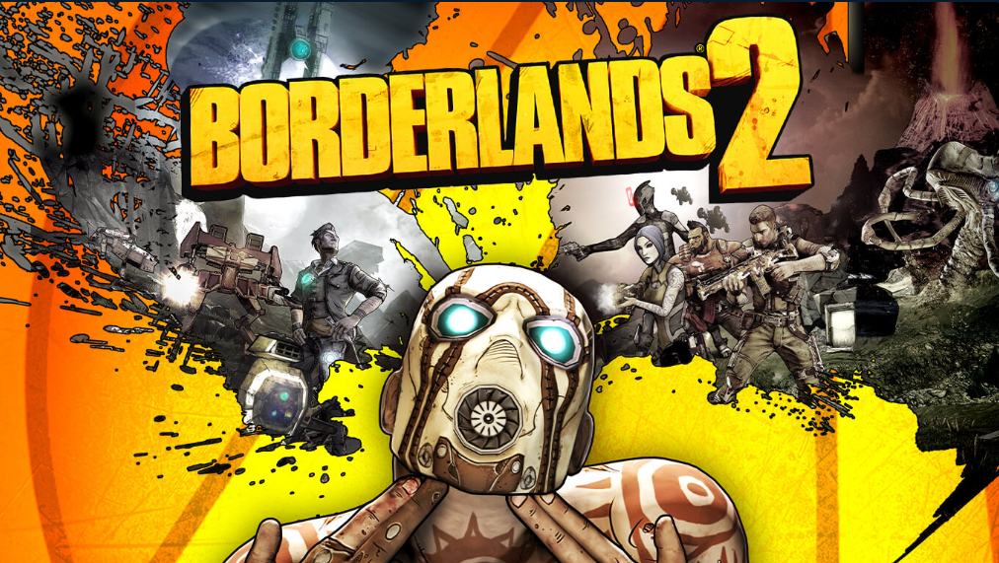
(Borderlands 2, Gearbox Software,2012,Available on Xbox One,PlayStation 4, Nintendo Switch, PlayStation 3, Windows)

In the opening of the first three Borderlands games the player meets Claptrap. A funny little robot that has a habit of talking peoples ears off. This character is more of a comic relief character. As each of the game starts Claptrap is in front of you filling the player in and giving them the backstory of what has been happening in the world. He also guides the player through the tutorial. Claptrap is not there in every step of the way but does appear in key points of the story and always makes his presence felt in the home base.
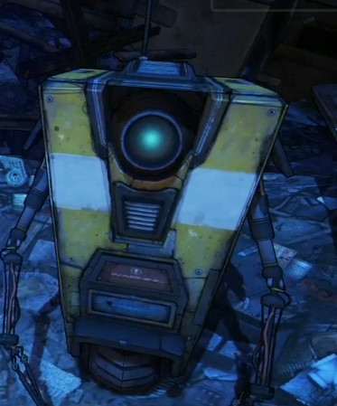

- Paimon from Genshin Impact-

(Genshin Impact, miHoYo,2020,Available on PlayStation 4, Android, PlayStation 5, iOS, Microsoft Windows)

In the start of Genshin Impact the player tells their backstory to Paimon who they just rescued. Paimon is similar to claptrap, a comic relief character. Paimon guides the player and gives all the world lore to the player. Unlike Claptrap Paimon is always by the player.

Implementation
Similar to game like these I wanted to introduce a supporting character to the player. As the player wakes up from the simulation, he is a bit dazed and confused and he first meets the small robot who tries to give the lore of the place and tries to guid the player. In my design I have tried to make this robot small and cute so the player would instantly like her. The other thing to sell to the player is the dialogue. Claptrap from Borderlands is a comical character and so most players would enjoy his company with an exception of a few who find it annoying. For my character I am taking the route of sympathy. Someone has wronged this small robot in the same was as the player so the player and robot can bond and find a common enemy.

Method of Manipulation-
How people manipulate their target-

- Bio Shock 1- “Would you kindly”-
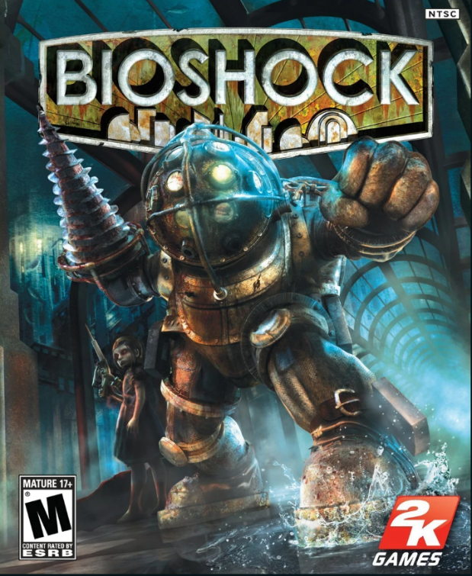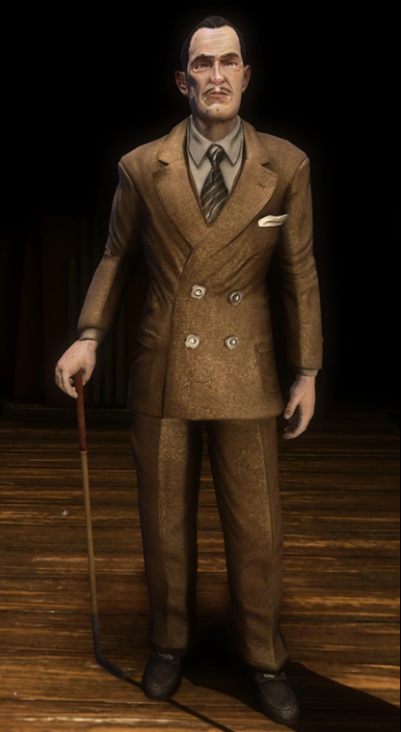
(Bioshock, Irrational Games, 2007, Available at Playstation3, Playstation 4, Xbox 360, xbox1, Windows.)

In Bio Shock 1 the main antagonist of the game uses the phrase “Would you kindly” whenever he wants the player to do something form him. The antagonist at first appears as a friend helping the player to sort the mess that has befallen the underwater city. At the end of the game the antagonist revels himself to be the bad guy and has been controlling the players action with the phrase “Would you kindly”. Apparently, the player had been brainwashed and when someone uses the phrase “Would you kindly” and ask the player to do something then they would do it no questions asked as though it were their own free will.

Implementation
In Bioshock 1 the antagonist uses the phrase “Would you kindly” as a specific trigger word. The player has been programmed in that manner. But in my game I want the player to feel that he and the little robot have a mutual understanding and that she is helping him as well as a victim of this evil corporation just like him. What I am taking from Bioshock 1 is how the antagonist and the player were people trying to save the city but in the end the player realises that the friend helping his is a bad guy. Similarly in my game I want the player to feel that the little robot and him are learning the dark truth of this company and are going to stop them only to find in the end that she has been manipulating him and that their journey was a lie.

- From the play of Julius Caesar- Mark Anthony- I played Mark Anthony in the play of Julius Caesar in my school and I have immense respect for this man. In the play Mark Anthony witnesses the death of Caesar by the hands of Cassius and Bruti. Cassius immediately feel that they should get rid of Mark Anthony as he is an eyewitness to this crime, but Bruti stops him and says that he is loved by Rome and he will let the citizens of Rome know how justice was served they had saved Rome from the tyrannical rule of Caesar. Mark Anthony understands his situation and surrounding and congratulates them for their deed. Cassius tell Mark to not say anything bad about them while Bruti says he should address the truth of what happened here. Bruti’s truth being Caesar was going to be a tyrant when he comes into power and so was slain to protect Rome. Mark agrees to the condition and addresses the crowd. But the way he delivers his speech is what gets to me. The way he delivers his speech Cassius and Bruti hear what they want to hear while the rest of Rome hear about the brutal murder and just like that sways the mob.

Relationship between main character and supporting character-
Games becomes more compelling when the protagonist has a character or characters that they can connect with. Based on the type of characters they are players have a strong emotional connection to them, either positive or negative. I am focusing on characters that players bond with. Examples-
- Last of Us 1- Joel and Ellie-

(Last of Us, Naughty Dog,2013, Available on PlayStation 3, PlayStation4, PlayStation5)

In Last of Us the opening sequence shows our main character Joel relaxing at home with his daughter. Later that night thing in the neighbourhood starts becoming weird as this infection has hit the streets. Normal life is thrown into chaos and so Joel, his daughter and brother try to flee the city. Caught in the chaos they lose their vehicle and try to make it on foot. Joel’s brother Tommy tells Joel to push forward as he block off the path behind them to prevent zombies chasing them. As Joel and his daughter Sarah push forward they run into a soldier who is ordered to prevent anyone from escaping the area by any means necessary. The soldier does inform command that the man has a child but command repeats their order. The begrudgingly aims his gun and shoots. Immediately after Tommy shoots the soldier. Joel luckily escapes getting shot but Sarah takes a shot to the stomach and then dies. This is a very powerful scene that show how badly Joel has lost someone close to him.
12 years later the infection has taken over and those uninfected live under martial law. Joel works as a mercenary and works with Tess. He and his partner get a job to transport a package across the country for an organisation called the Fireflies. The package turns out to be a little girl called Ellie who is immune to the virus. During their journey Tess gets infected and so sacrifices herself by blowing herself up and giving time for Joel and Ellie to escape. After losing his partner Joel takes it upon himself to make sure this girl reaches her destination no matter what. As they continue on this journey Joel sees Ellie as a kid who did not get to experience a proper childhood because of the world’s current state. Slowly and unconsciously starts replacing her as his own daughter. When Joel finally reaches the destination and deliver her to the Fireflies he finds out they intend to do an autopsy on Ellie and study her brain as that appears to be the source of her being immune to the virus. This was a very conflicting feeling for Joel to just let her die. He could not lose his daughter again. So he kills everyone and gets Ellie out of there. This is how the game ends. Joel scarifies potentially finding the cure to save the world for Ellie’s safety.
In this game relationship between the two changes from professional to father and daughter. The goal of the game was simple where Joel had to simply deliver Ellie from point A to point B but the journey is what changed the character. The more they progressed in their journey the more he saw Ellie as his daughter and as the player you understand and feel for both characters.

Implementation
Similar to the Last of Us I want the player to have a strong emotional connecting with the little robot ERIS. I am not going the same path as Last of Us did where they had a father daughter relationship. I am targeting more over of a sympathetic friend and fight justice for them sort of a relationship. Using ERIS as the first character the player sees and ERIS giving all the information and lore about the place and what is happening show her to be a character that is just there to keep feeding info to the player. Sort of like a character in the backseat. But as the player what happened to ERIS and what this company has done to her and is doing to everyone, I want the player to feel sorry for her and brave forward as her being his trusted partner bring her into the passenger seat.

- The Karate Kid(2010)-

(The Karate Kid, Harald Zwart ,2010, Available on Amazon Prime)

Dre Parker and Mr.Han- In this movie Dre moves from the US to China as his mom gets a new job. After coming to China Dre is not accepted by a group of kids who find him different and bully him. Mr.Han was called to Dre’s house to fix the water heater and he sees Dre trying to learn martial arts my mimicking what was happening on the TV. This is how the two get acquainted. A few days later Dre gets tired of the bullies and so tries to take revenge on them by dropping dirty water on them. The bullies immediately start chasing Dre, catch up to him and start beating him up. Mr.Han who happened to be passing by saves Dre. The next day he and Dre go to the kung fu dojo where the bullies are. Mr.Han tries to resolve the issue with the dojo master but the master cannot let the person who hit his students simply walk away. So Mr.Han challenges the master by saying he will train Dre and will defeat them in the upcoming martial art tournament. Mr.Han then starts training Dre in Kung Fu. As they train Mr.Han sees Dre to be a kid who is little undisciplined and has an attitude and as he trains Dre in Kung Fu he sties to discipline him. Later Mr.Han reveals his own tragic story of how he lost his own wife and son in a car accident and Dre tries to comfort Mr.Han. So now they have this strong bond of master and student. Dre then joins the tournament and faces off against many opponents including his bullies. During the semi-finals of the tournament the enemy master asks his student to break the rules and just hit Dre and make sure he cannot take part in the finals. So when the fight begins the bully knocks Dre down and keeps hitting his leg. The bully is then disqualified and Dre is taken to the medical room. Dre then asks Mr.Han to do the same type of healing that he did after Dre was thrashed by the bullies. Mr.Han at first does not feel like doing it and asks “You have already proven yourself?” to which Dre say “You told me when life knocks you down, you can choose whether to get back up. I am choosing to get back up so why won’t you help me?” To which Mr.Han responds “I watch you get hurt anymore.” Dre requests Mr.Han to help him and Mr.Han asks why is he pushing himself so hard. To which Dre says “Because I am still scared and no matter what after tonight I don’t want to be scared anymore.” And so Mr.Han heals him and gets him back up. Dre then goes and faces the leader of the bullies and wins the fight earning respect in his bullies eyes.
So just like in Last of Us the relationship between Mr.Han and Dre starts professional which then becomes a strong bond between master and student. Mr.Han believes in Dre and knows he is good enough to win the tournament but when Dre gets hurt he does not feel like helping Dre as it hurts him to see Dre in pain but when Dre pleads Mr.Han to help him, he sees the determination in Dre’s eyes and so helps Dre because he wants to face his fears, his bullies and finish this once and for all.

Implementation
This sort of relationship of trust what Mr.Han and Dre had in each other is what I and trying to have between the player and ERIS. I want the player to feel bad when the horrific truth of ERIS’s background is reviled and to follow through with her resolve of bringing this company down.

A villain for the protagonist to fight
In some movies and game there are times where the viewer can predict who the mysterious villain is by following a trail or clues that make it pretty obvious but then the viewer finds out that those clues were just misleading as the obvious villain but it turns out they are just misunderstood characters, either innocent or partly to blame for what happens but not the mastermind behind it all.

- Pokémon Detective Pikachu- Roger Clifford and Howard Clifford- In this movie what Tim receives the news his dad is dead. He goes to his dad’s place to collect his things are runs into his dad’s Pokémon partner how he can understand. Pikachu then tells him that he needs to investigate the case his dad was on. As Tim is gradually getting closer to the truth the cities visionary Howard Clifford reaches out to him saying that Tim’s dad was working with him and finding the source of a mysterious R gas that makes Pikachu extremely aggressive and Howard gives the location of the lab to Tim. As Tim and his friends head down to that lab they are being watched by Howard’s son Roger Clifford. He releases the crazed Pokémon that then attack Tim and his team. As they are escaping out of the area Pikachu gets injured. As Tim is freaking out a heard of Bulbasaur approach Tim and lead him to a Mewtwo. The Mewtwo heals Pikachu and then is immediately captured by Roger’s team. Roger then brings the Mewtwo to Howard who turns out to be the true bad guy.
So throughout the movie Roger appears to be an arrogant douchebag how seams to hate his father as he is stuck in his shadow. So when Rojer appears in every suspicious scene in the background like releasing the crazed Pokémon from their prison as Tim and his team are exploring the lab and when he captures Mewtwo leads the viewers to believe that he might be the bad guy behind everything but then it turns out that Roger was a prisoner of his father and the one how has been in all the scenes was Howards’ Pokémon Ditto disguised as Roger. So here the obvious villain was a turned out to be innocent.

- Until Dawn- Josh and Wendigo- Until Dawn is a horror choice-based game. Each action of the player determines whether the character in the game would live or die. The game has a very similar vibe to the Cabin in the Woods where these tweens go to one of their friend’s lodge. There are 9 characters the player gets to switch between and play as the story progresses. There is Hanna, Beth, Josh, Sam, Ashley, Chris, Matt, Emily, Mike and Jess. Viktor Milgram is a suspicious character that is always being in the background with his face being covered and holding a machete. Leading everyone to this he is a bad guy. Mike, Jess, Emely, Matt and Ashley play a horrible play a prank on Hanna. Which leads to Hanna and Beth’s death The authorities do their best but are unavailable to find their bodies as so close the investigation. A year later the older brother of the two calls the group and asks them to come back to the lodge to have their annual reunion. One by one the group meet up by the lodge with some of them being stalked by the mysterious Viktor Milgram.
As the night progresses the group split and go is 3 different directions. The ones in the main lodge are tortured by a mysterious psycho and Josh gets killed. When Chris and Ashley escape the shed to head back into the Lodge they run into Matt and Emilie informing them what had happened. Matt and Emillie head off to the radio tower to call for help while Chris and Ashley head back to the lodge get captured again. Meanwhile Jess gets kidnapped by someone and is dragged into the mines. Mike chases after it as far as he can and then follows Viktor Milgram thinking he is the killer. Mike follows Milgram into a sanatorium that connects to the basement of the house. Mike reunites with same and together go to rescue the captured Chris and Ashley. The psycho takes off the mask to reveal himself to be the dead Josh. Josh had faked his death and mentally tortured his friends to take revenge for what happened to his sisters. Josh laughs it off calling it a prank but Mike gets pissed off as he thinks that it was Josh’s fault that Jess is dead. Meanwhile Matt and Emilie call for help and as soon as they do that the tower starts falling. Matt manages to jump to safety but Emilie falls into the mines. In the mines she is then chased by a Wendigo. Emilie narrowly escapes the wendigo and somehow makes it to the lodge. Soon after she makes it back there is a knock on the door. It happens to be Viktor Milgram. He tells the group that they should have not returned after what happened las year as this mountain is possessed by the sprite of the wendigo. The wendigo is a Native American Lore. It is said that whoever resorts to cannibalism is then possessed by the sprite of the wendigo. Emilie informs that the park ranger can help them escape but will be here at dawn at the earliest. From there the group has to survive from being killed by the Wendigo.
The game Until Dawn opens itself with all sorts of horror cliché throwing the player off. Josh and Viktor Milgram are the obvious seen bad guys for the player to be cautious about but the reality turns out to be that Josh is suffering from schizophrenia and take it too far when it comes to a revenge prank on the group and Viktor Milgram is a native of the land who is trying to protect people form the wendigo. While the true monster was the Wendigo.

- Harry Potter Series- Professor Snape- Throughout the entire series Professor Snape has been shown as the bad guy. He is shown to have hated the main protagonist Harry Potter as soon as Harry comes to Hogwarts. Through the series he has been hard on Harry. In the movie and book the Half Blood Prince it is revealed that Snape works for the bad guy Voldemort and in the end kills the headmaster. So throughout the series he is established to be a bad person but after he kills the headmaster Snape is seen as a certified bad guy. Towards the end before the final fight Voldemort fatally injures Snape and leaves his to die. Harry then collects his tears and find out that Snape is actually a double agent who was always working for headmaster Dumbledore. Even the death of Dumbledore was planned. The biggest secret Snape kept was that he was always in love with Harry’s mother Lily Potter. Snape was a silent guardian watching over Harry and keeping him safe. Snape was a tragic hero looked as a bad guy because he was too good as a double agent and so could not break his cover no matter what.

Implementation
The enemy I have build here for the player to go against is the Twin Titan Corporation. This company was once hailed as a hero that brough world piece is now committing heinous crimes all in the name of safety. So here I am giving a bad guy like they did with Professor Snape but at the same time the company is a fake villain as the true villain in the game is ERIS herself. Since the entire game is a simulation on manipulating and conditioning people to do things, the Twin Titan Corporation is a fabricated enemy, and it has a fabricated story just to convince the player that this company is really doing something bad and it is up to his and ERIS to stop them.

Environmental Sound-
- Resident Evil 2 remake- Tyrant-
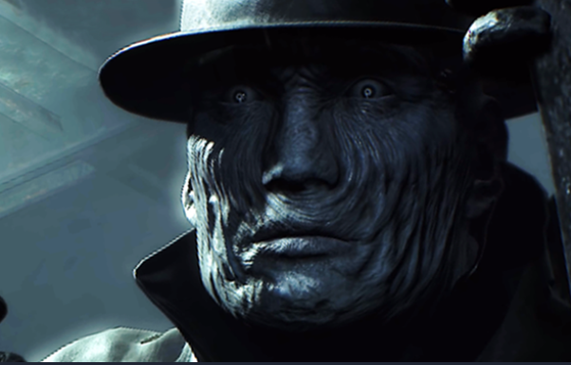
(Resident Evil 2 Remake, Capcom,2019, PlayStation 4, PlayStation 5, Xbox One, Xbox Series X and Series S, Microsoft Windows)

Resident Evil 2 remake does a phenomenal of bring a cult classic to modern graphics and mechanics. One of the things the game does extremely well is with audio as they play a lot with binaural audio. In the start of the game the player gets to choose to pick between Leon or Clera. The first map is the police station. The police station is filled with different zombies and the players objective is to find a secret passage that can help them get out using a underground tunnels. As the player makes progress a new type of enemy show up called the tyrant or Mr.X. This enemy cannot be killed. He can take a number of bullet shots that can knock him down for a short duration bit then gets right back up to cause havoc. It is in the players best interest to just outrun the tyrant and save the bullets while focusing on the objective. One of the scariest thing is that when the tyrant is close by the player can actually hear the foot steps marching. The player then absolutely needs to keep quiet or else the tyrant comes for them.

Implementation
In Conditioning the tensed part if when the player is traversing through the defence mace that is being patrolled by the H3R05. I wanted to add to the tension as was as warn the player by adding footstep noise to the patrolling H3R05 that get louder when closer.

Immersion Plan
Conditioning is a FPS stealth game. To immerse my player I am not going to give the player any backstory or dialogues. By doing this I am not forcing the player to role play as someone else and rather let them be themselves.
ERIS has all the dialogue as she is the source of manipulation so when the player discovers the sad backstory of ERIS I want the player to sympathise with her and try to help her in a way they can.
To sell the illusion that this corporation is bad I fleshed out an entire backstory, coming up with a timeline from when this corporation was established to how it has fallen in the present day. Driving and giving the player an enemy to go up against.
As for the environment the place the player is trapped in a secret facility, So I have applied a brutalism architecture and keeping the environment low lit. This way the player’s vision is near sighted keeping the tension for the player high.

Game Flow Chart

Game Flow

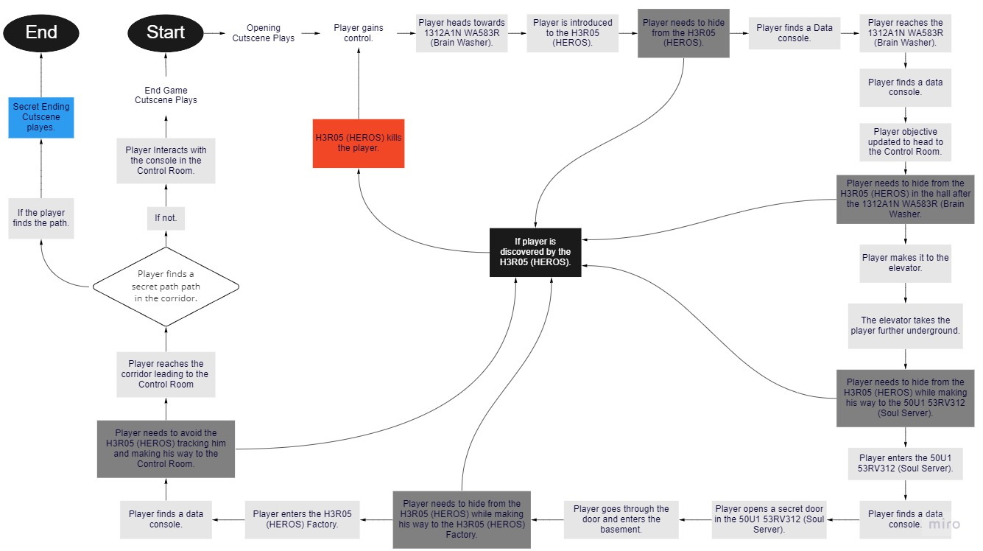

Narrative Flow

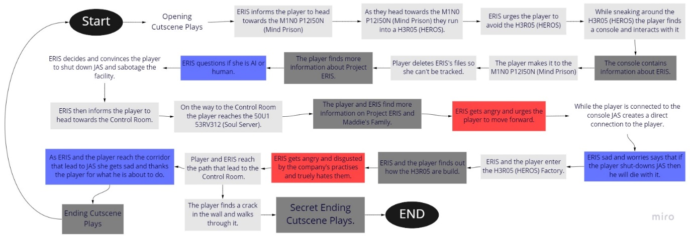

Starting Cutscene End Game Cutscene

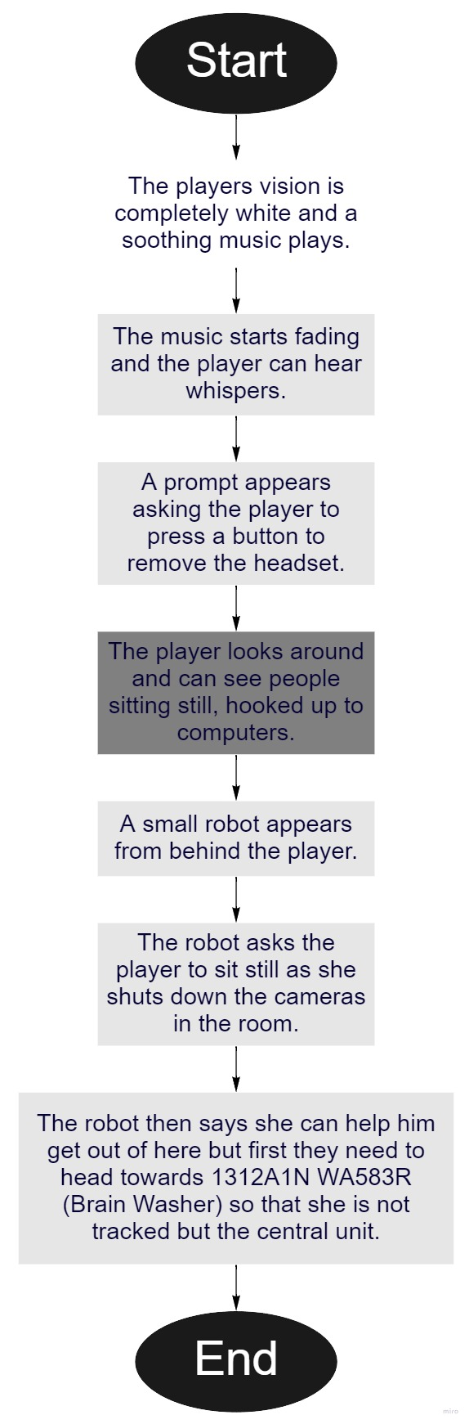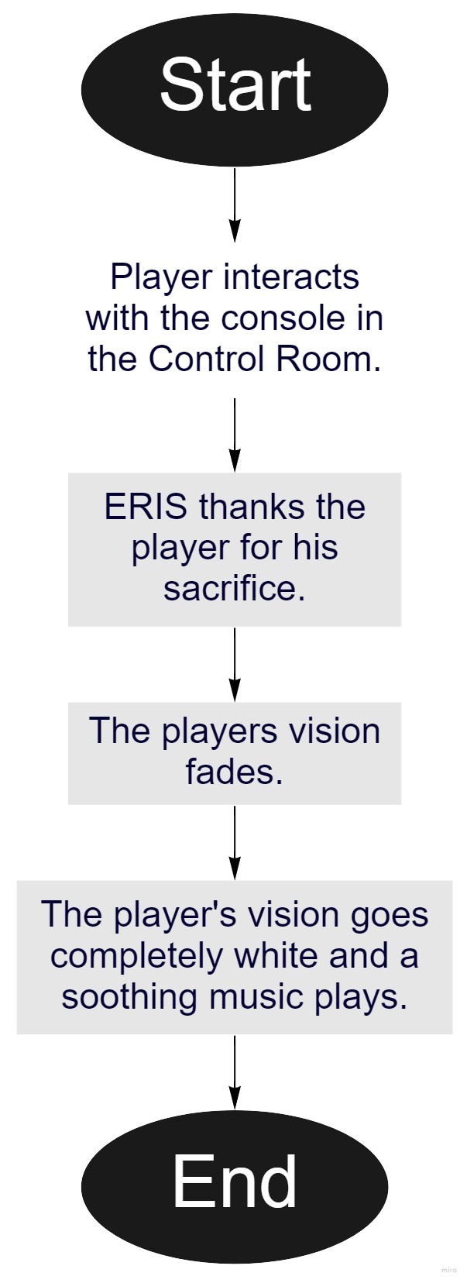

Secret Ending Cutscene

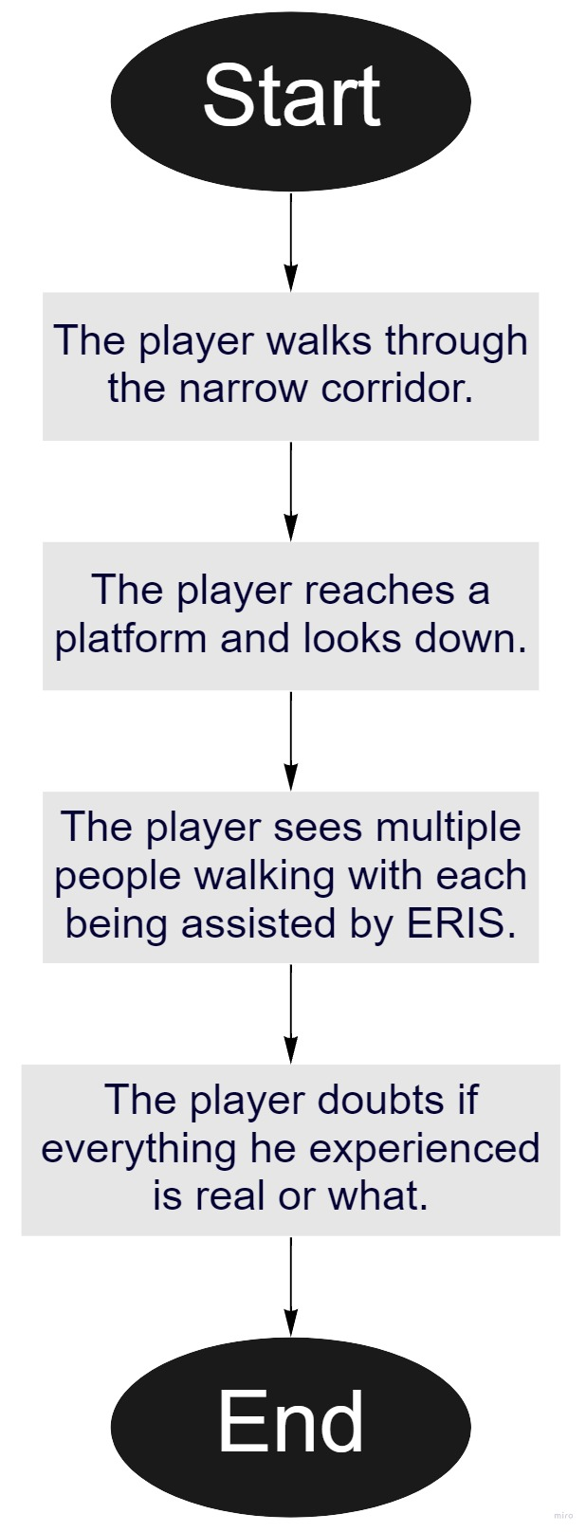

Game-Over Flow

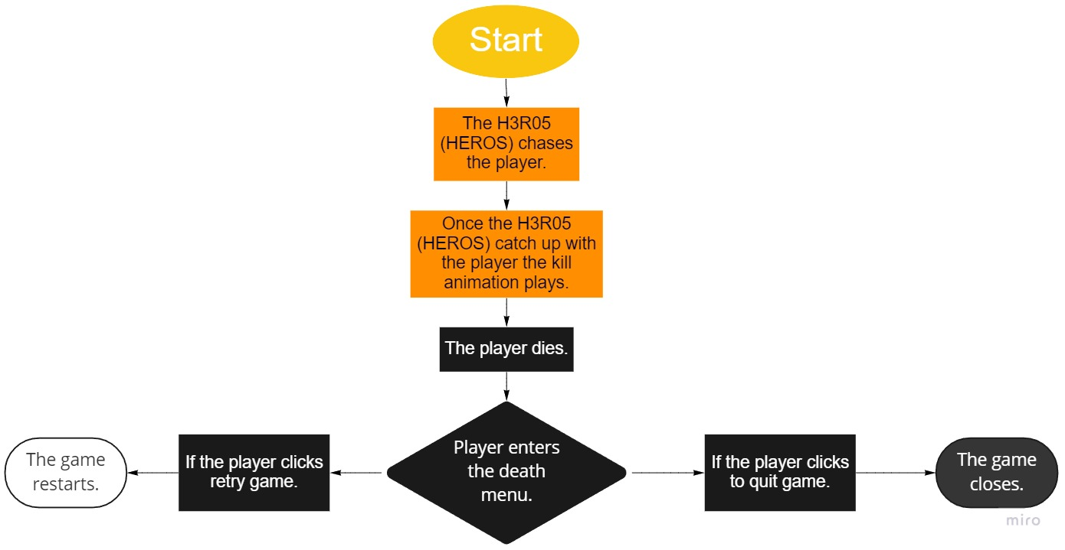

Dialogue Script

Game starts
Game starts with a music. The main character’s vision is white. A few seconds later the volume of the music reduces, and the main character (MC) can hear whispers.
A prompt appears to take off the head gear.

First Cutscene Starts
The MC wakes up distorted. Trying to gather his senses and get a sense of his surroundings. As the MC scans the room. A voice from behind whispers.

[ERIS] “Oh wait!.... You are awake?..... You were able to break through the system?”

The MC turns around and looks at a small bot talking to him.

[ERIS] “Don’t make any sudden movements. They are watching. Ill disable the cameras in the room. “

The ERIS goes to the console and disables the camera.
The ERIS comes back to the MC.

[ERIS] “The cameras are down. You can move now.”

The MC gets up and starts walking around.
First Cutscene Ends

Please Check Script Document for full Script

Mood Board

Environment

Mind Prison Room Art Reference-
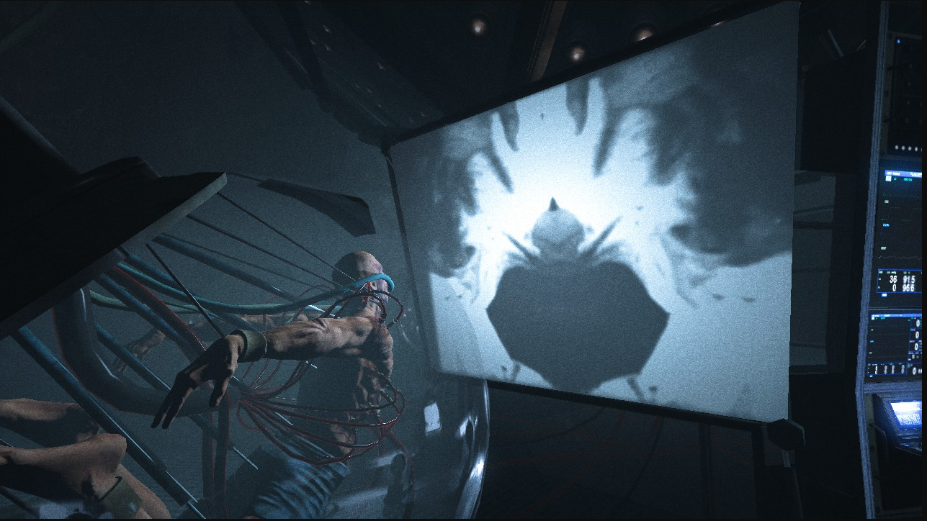
(Outlast 1,Red Barrels,2013,Available on PC)

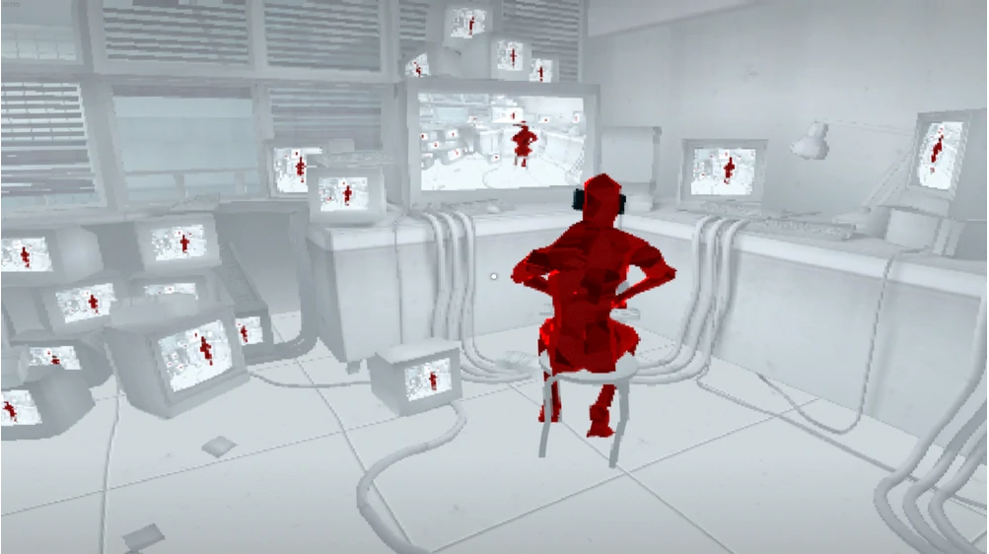
(Super Hot,SUPERHOT Team,2016,Available on PC,PS4,Xbox 1,Switch,Oculus Quest)
(The ending of Super Hot show how the player is controlled)
These are a reference to how I imagined the Mind Prison to be. The player trapped in the system.

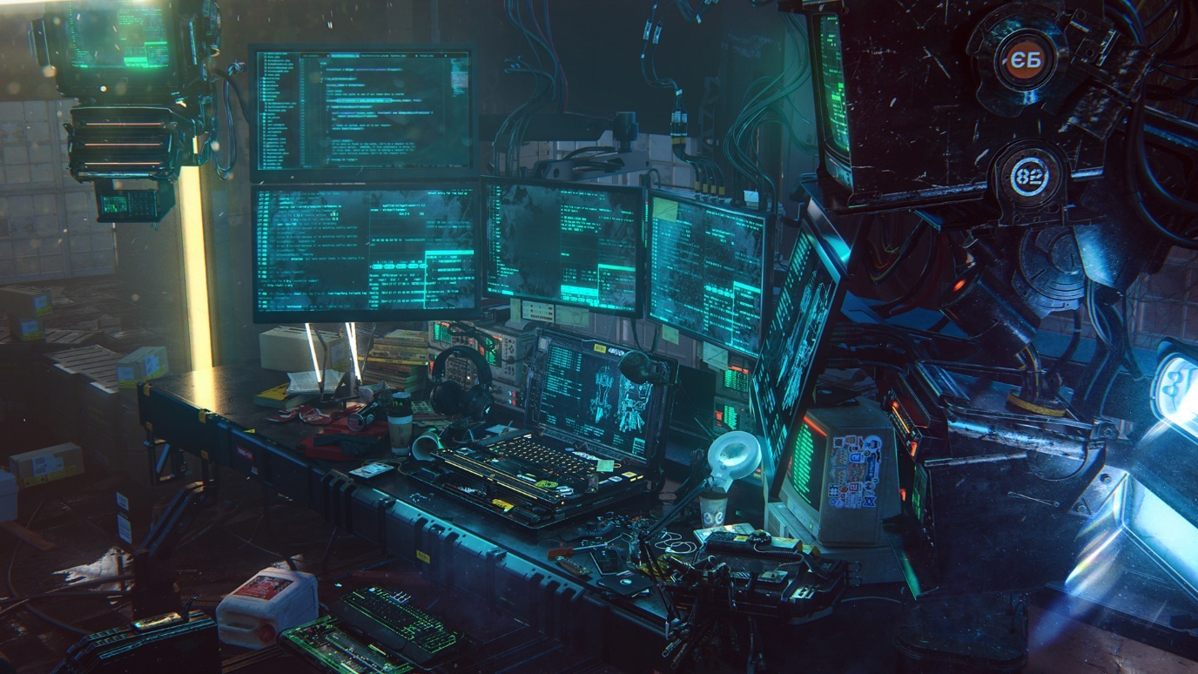
(3D C4D Redshift Cyberpunk Hacker Scene,Creatiflux,2020,Available on Turbosquid.com)
This is how I imagined the Work setup to be like. The player wakes up disconnected from the system and the setup looks like this. When the player looks around there are people connected to a setup like this.

Brain Washer Room Art Reference-
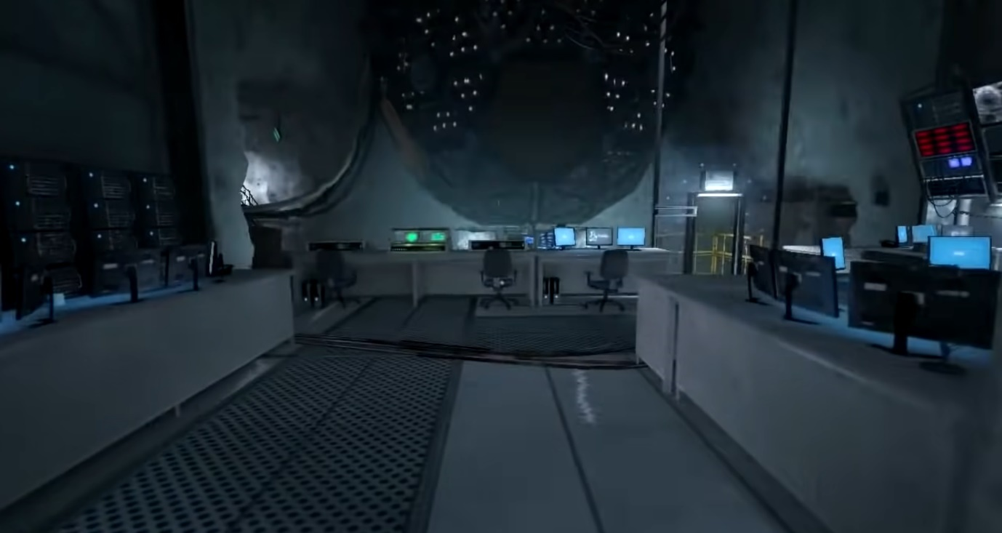
(Outlast 1,Red Barrels,2013,Available on PC)
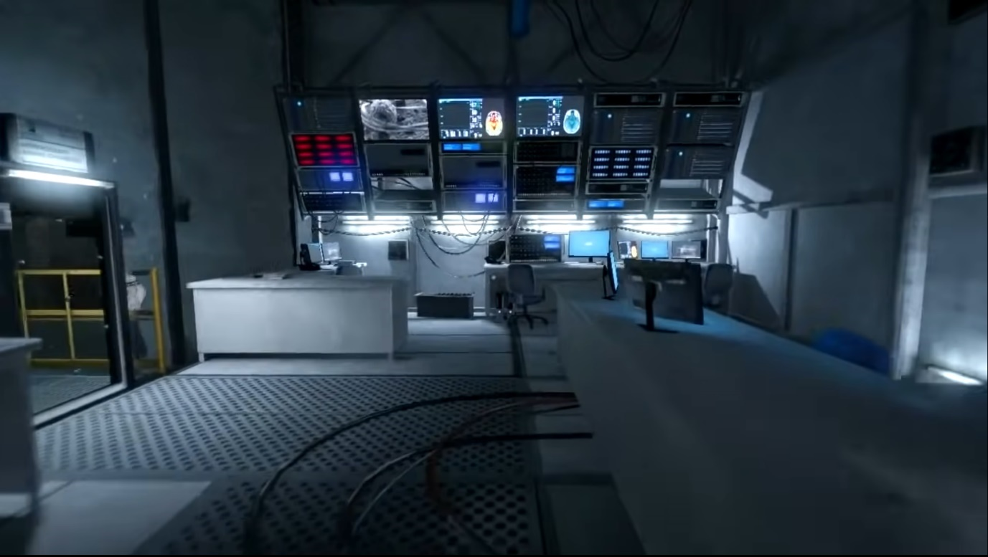
(Outlast 1,Red Barrels,2013,Available on PC)
As the Brain Washer Room is a self-monitored room that keeps a check on ERIS. I imagen it to be mostly filled with screens and no need for human control or supervision.

Soul Server Room
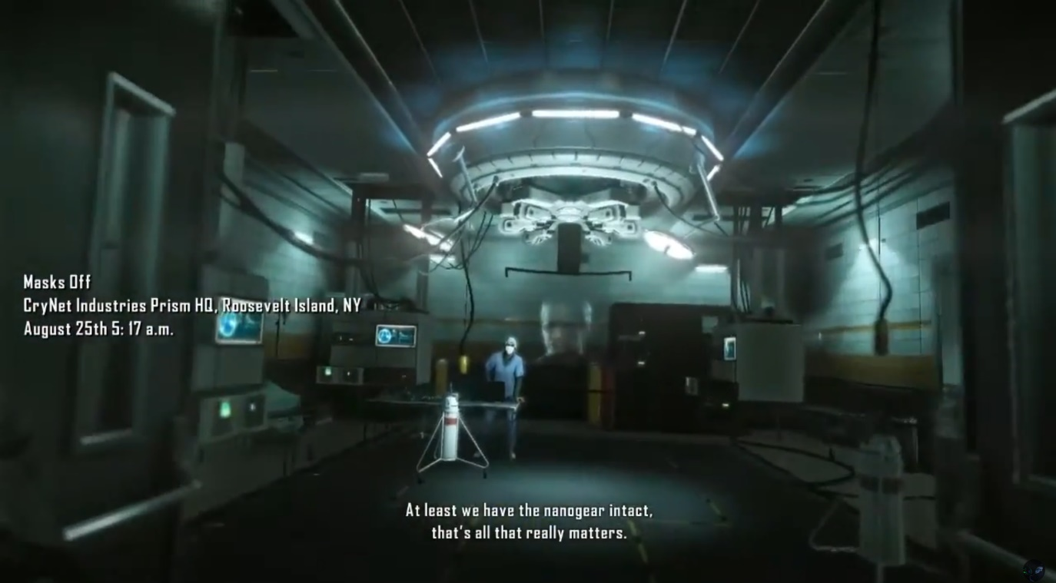
(Crysis 2, Crytek,2011, Available on Nintendo Switch,PlayStation 4,Xbox One,PlayStation 3,Microsoft Windows,Xbox 360)
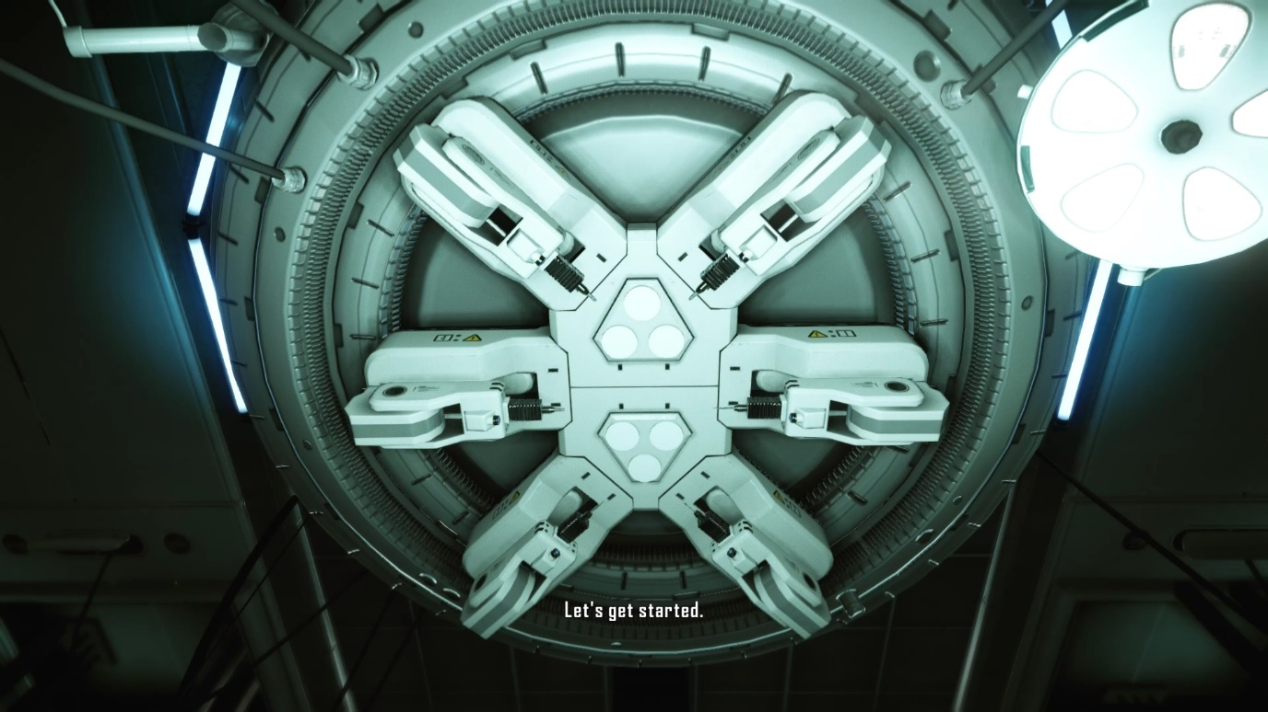
(Crysis 2, Crytek,2011, Available on Nintendo Switch,PlayStation 4,Xbox One,PlayStation 3,Microsoft Windows,Xbox 360)
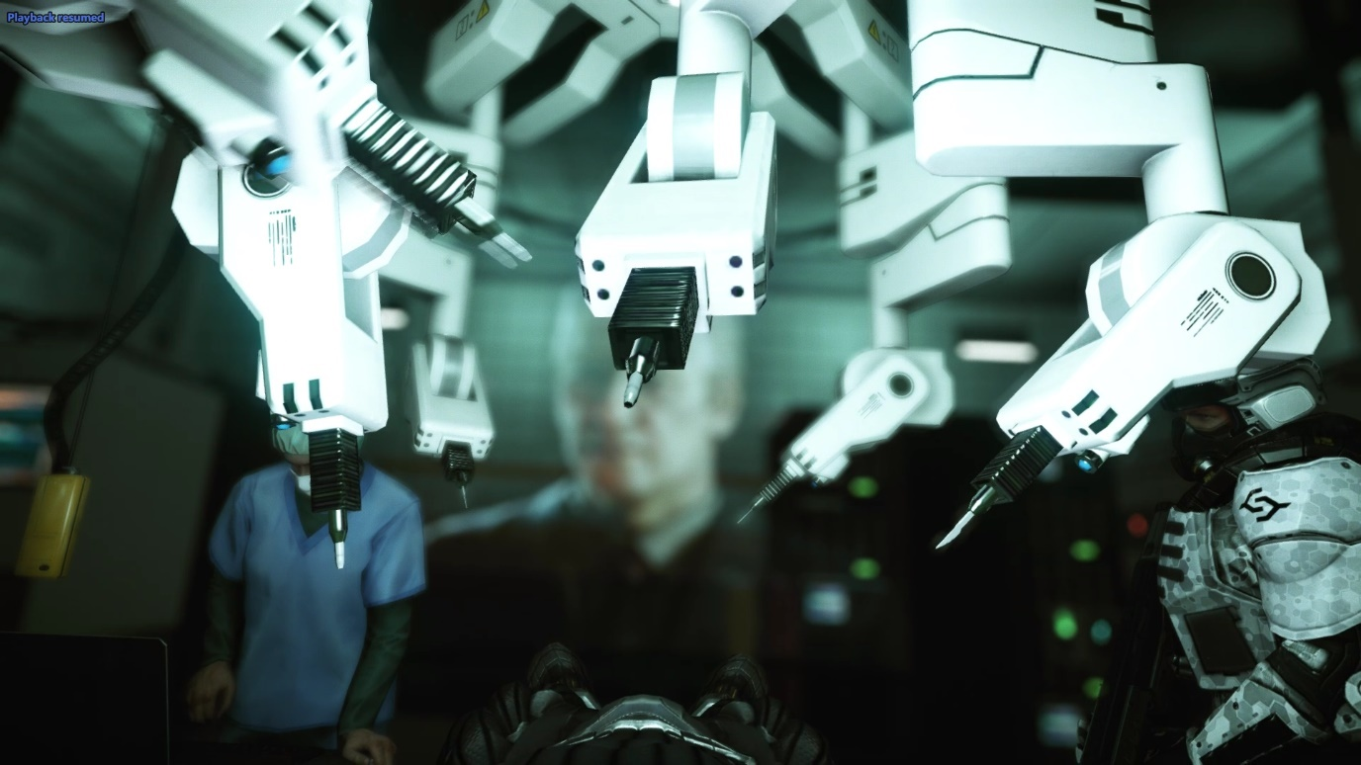
(Crysis 2, Crytek,2011, Available on Nintendo Switch,PlayStation 4,Xbox One,PlayStation 3,Microsoft Windows,Xbox 360)
(The skinning lab in the Prisim)
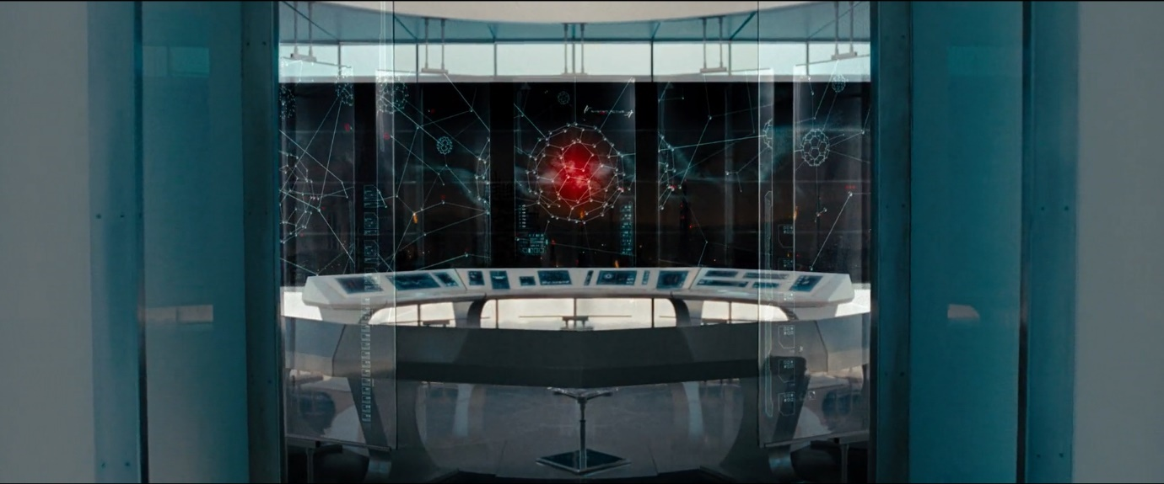
(Terminator Salvation,Columbia Pictures,2009,Available on Amazon Prime)
(The main room in Skynet that build Marcus)

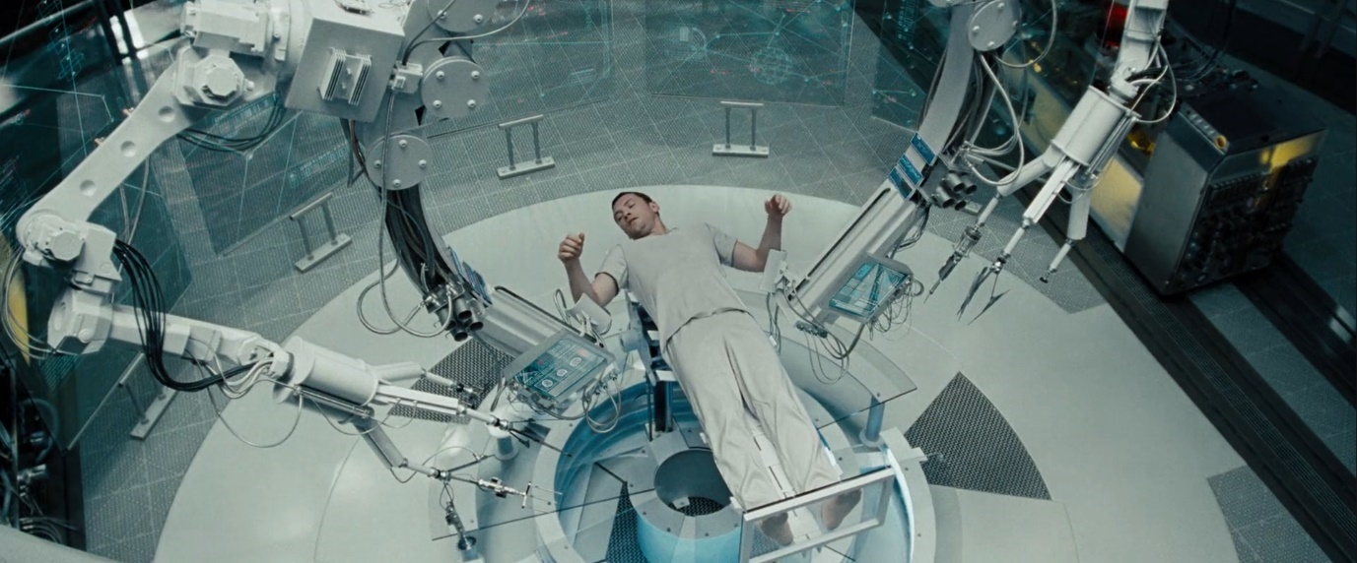
(Terminator Salvation,Columbia Pictures,2009,Available on Amazon Prime)
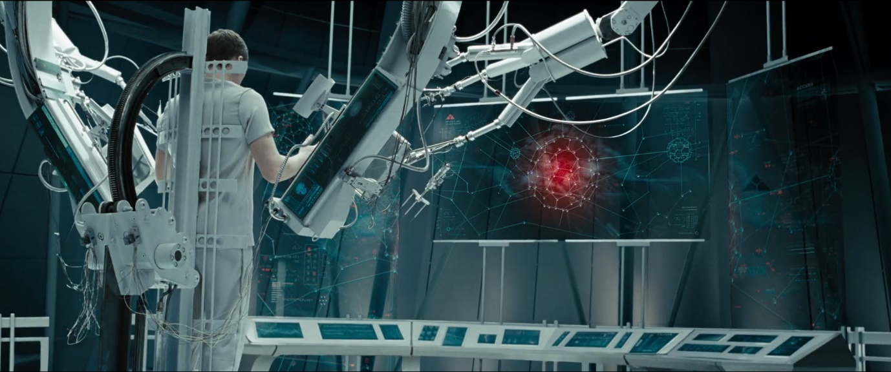
(Terminator Salvation,Columbia Pictures,2009,Available on Amazon Prime)
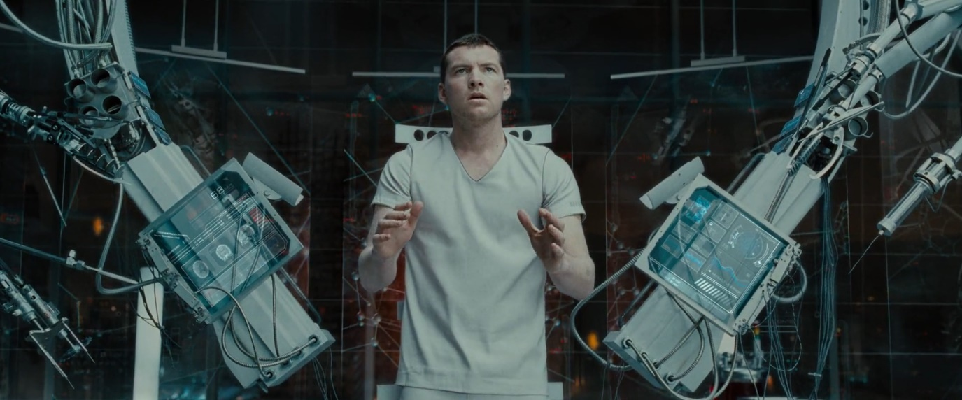
(Terminator Salvation,Columbia Pictures,2009,Available on Amazon Prime)
The Soul Server room is a space where people are operated on and their psyke is extracted and stored into a server which is then later used to create an AI. So I imagen it to be the room to have an operation table with a primary screen to interact with the system and a lot of server machines and CPUs to process the conversion of peoples soul to AI.

Control Room Reference
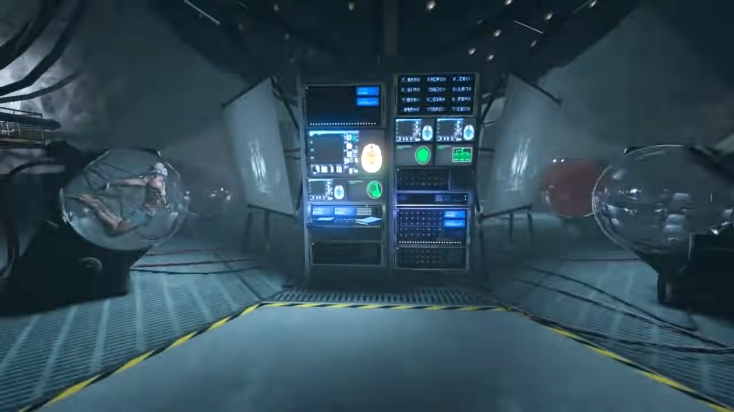
(Outlast 1,Red Barrels,2013,Available on PC)
(The computer that controls the Wall Rider)
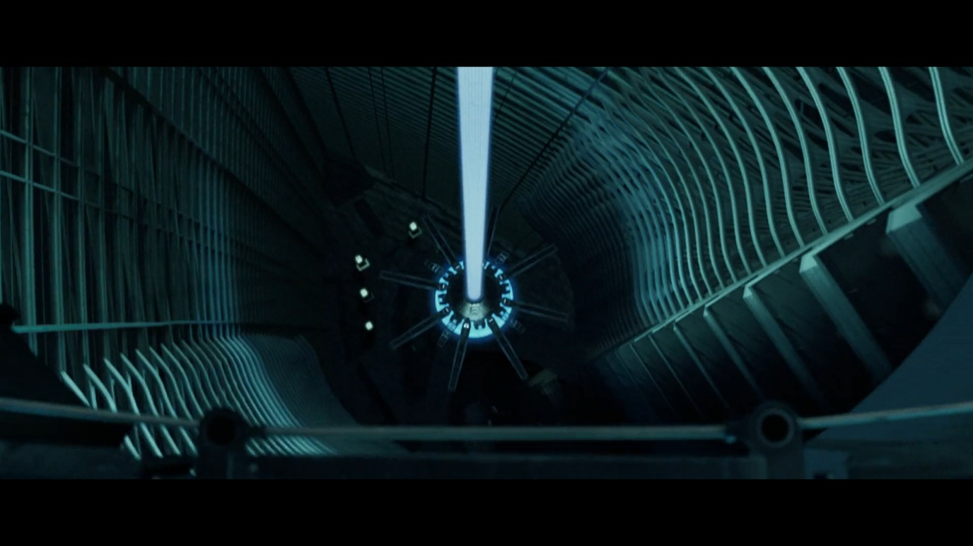
(I Robot, Alex Proyas,2004,Available on Disney+)
(Viki’s actual processor)
The Control Room is a final destination. It is the room where the main AI JAS that monitors the facility is and the player needs to shutdown this system. I more of imagen this room to have a vertical monitor panel and a whole lot of computers to run and control this space as well as have a giant computer in the middle.

Characters

ERIS Reference-
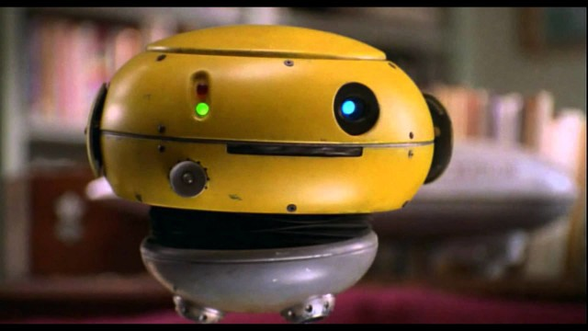
(Flubber, Les Mayfield,1997,Available at Disney+)
(The small robot in Flubber)
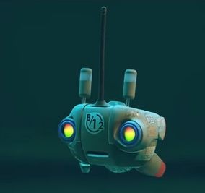
(Stray, BlueTwelve Studio,2022,Available on PlayStation 4, PlayStation 5, Microsoft Windows)
(The small robot that help the cat is stray)
I always imagined ERIS to be a innocent looking robot that the player can trust and not have any suspicions.

H3R05 Reference

(Optimus Prime,Transformers,2007,Available at Amazon Prime)
For the AI patrolling I wanted to have an imitating presence. I wanted to use an AI with the lack of facial features making them more ere to look.

Lighting

Resident Evil 7
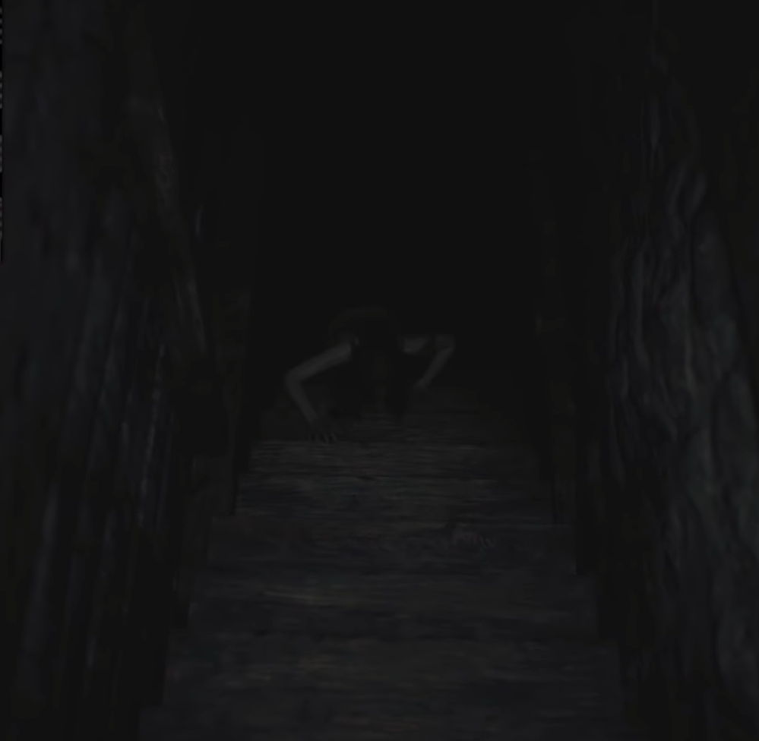
(Resident Evil 7, Capcom,2012,Available on PlayStation 4, Nintendo Switch, PlayStation 5, Xbox One, Windows PC)
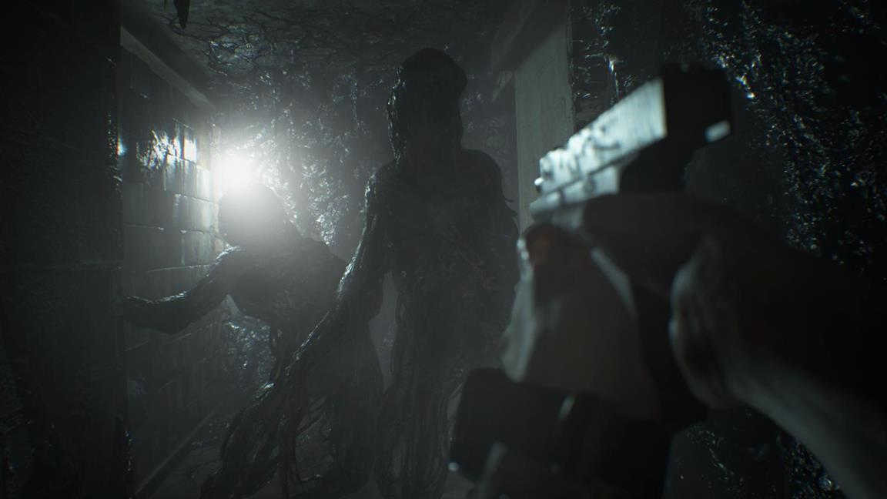
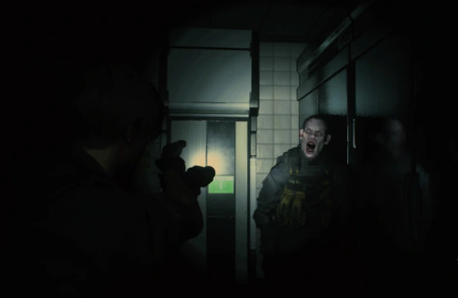
(Resident Evil 2 Remake, Capcom,2019, PlayStation 4, PlayStation 5, Xbox One, Xbox Series X and Series S, Microsoft Windows)
I want to have low lighting in the halls and maze but have a bright source of light when the player is in one of the main rooms.

Maze structure Reference

Maze Runner Walls-
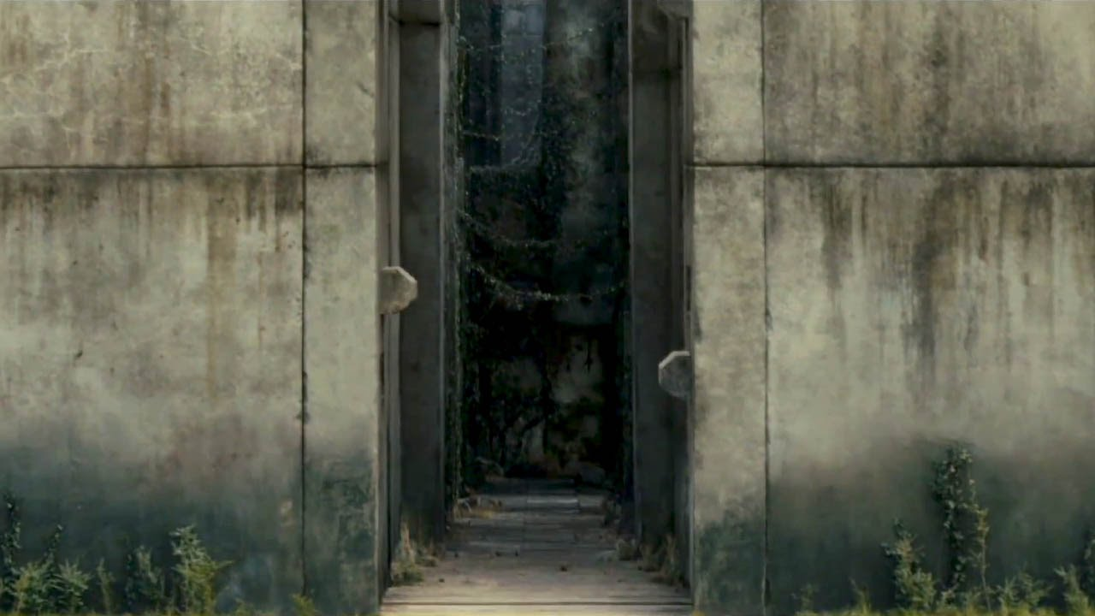
(Maze Runner, Wes Ball, 2014, available on Disney+)

Life is Strange 5 Episode 5
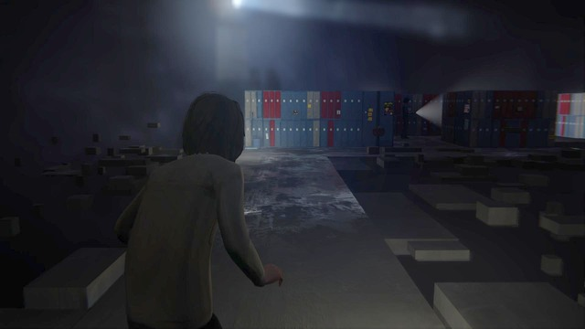
(Life is Strange, Don't Nod, 2015,PlayStation 4, PlayStation 5, Xbox One, Xbox Series X and Series S, Microsoft Windows)
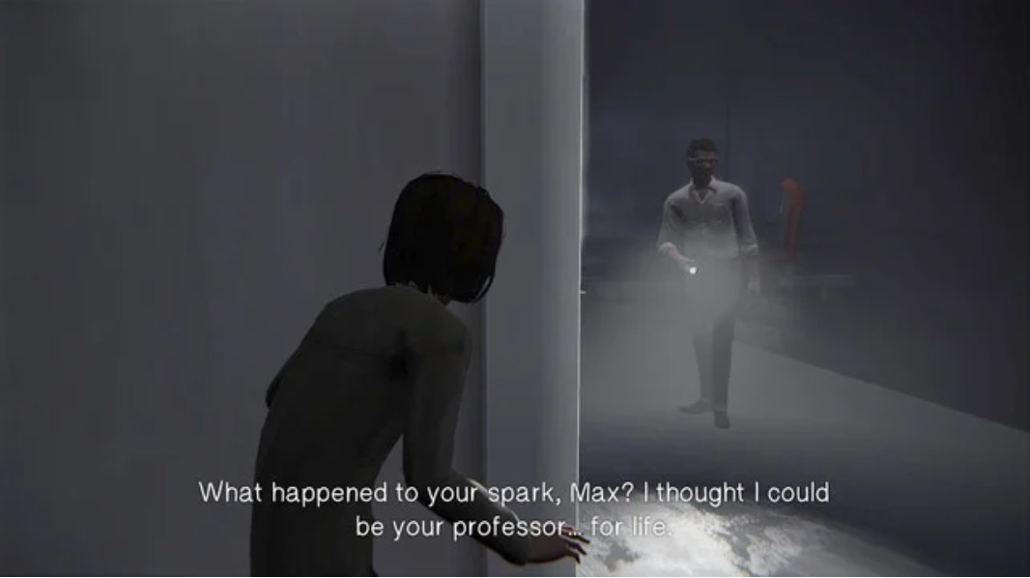

Maze Intensity Reference

Life is Strange 5 Episode 5
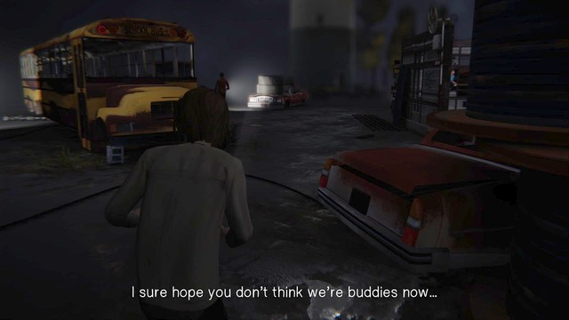
(Life is Strange, Don't Nod, 2015,PlayStation 4, PlayStation 5, Xbox One, Xbox Series X and Series S, Microsoft Windows)
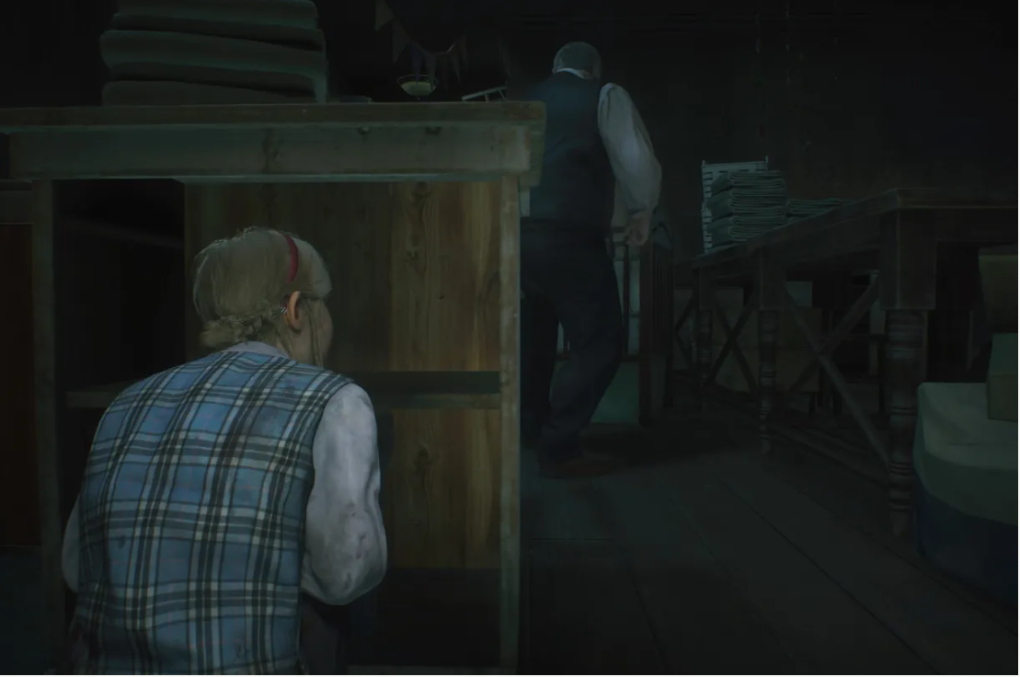
(Resident Evil 2 Remake, Capcom,2019, PlayStation 4, PlayStation 5, Xbox One, Xbox Series X and Series S, Microsoft Windows)
In both games during the maze section if the are seen once it is game over as so this the type of intensity I want to bring into my maze section as well.

References

Assets Used in Game
Sci-Fi Interior Pack-
(Sci-Fi Interior Pack , Andrei Grebenshchikov, 2020, Available on Unity Asset Store)
Cyberpunk - Urban Steel0-
(Cyberpunk - Urban Steel, IL.ranch, 2022, Available on Unity Asset Store)
LowPoly Server Room Props-
(LowPoly Server Room Props, iPoly3D, 2021, Available on Unity Asset Store)
Dental Chair-
(Dental Chair, Rokay3D, 2018, Available on Unity Asset Store)
Floor materials pack v.1-
(Floor materials pack v.1, VK GameDev, 2019, Available on Unity Asset Store)
Painted UI
(Painted UI, Soti, 2019, Available on Unity Asset Store)
UI Samples
(UI Samples, Unity Technologies, 2021,Available on Unity Asset Store)

